Week 3
210905212_aashish
sample1:
import numpy as np
#1d and 2d array
A = np.array([2,4,5,10])
print(A.dtype)
print("----------------")
B = np.array([2.4,5,10])
print(B.dtype)
print("----------------")

print("2d array")
A=np.array([(3,4,5),(12,6,1)])
print(A)
Z = np.zeros((2,4))
print(Z)
O = np.ones((3,4))
print(O)

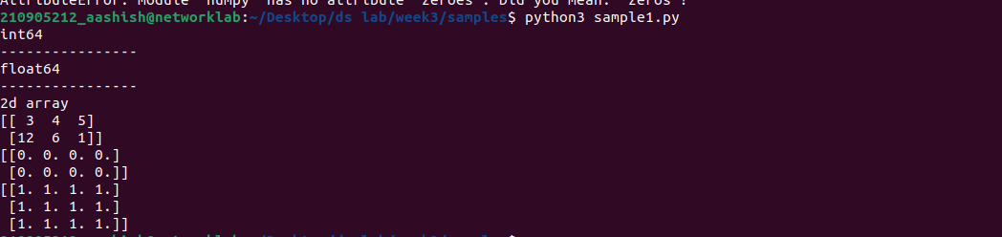
2)
import numpy as np

S = np.arange(10,30,5)
print(S)
Z = np.arange(0,2,0.3)
print(Z)
S1 = np.linspace(0,2,9)
print(S1)

print("-------------")
print("random no:")
import random

print(random.choice([1,2,3,4,5]))
print(random.choice('python'))
print(random.randrange(25,50))
print(random.randrange(25,50,2))
print(random.random())
print(random.uniform(5,10))
my_list=([1,2,3,4,5])
random.shuffle(my_list)
print(my_list)
random.seed(10)
print(random.random())
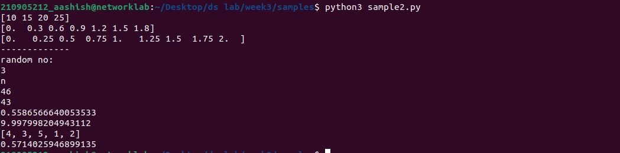
q3)
import numpy as np
a=np.arange(15).reshape(3,5)
print(a)#print
print(a.shape)#size
print(a.T)#tranpose
print("-----------")
c=np.arange(24).reshape(2,3,4)
print(c)
print(c.shape)
print("--")
print(c[1,:,:])
print("—")
print(c[:,:,2])
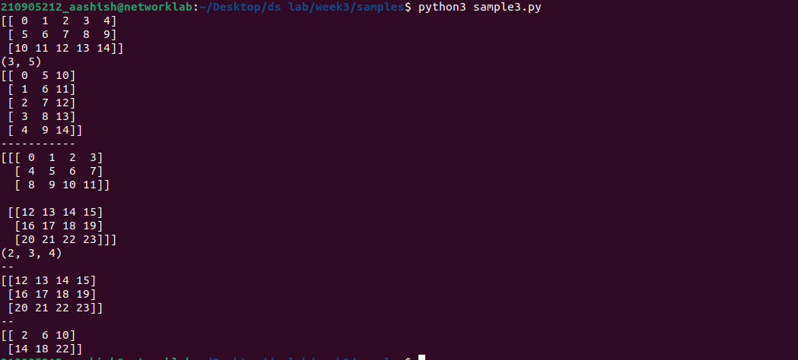
s4)
import numpy as np
print("array operations")
a=np.array([20,20,40,50])
b=np.arange(4)
print(b)
c=a-b
print(c)
print(b**2)
print(10*np.sin(a))
print(a<35)
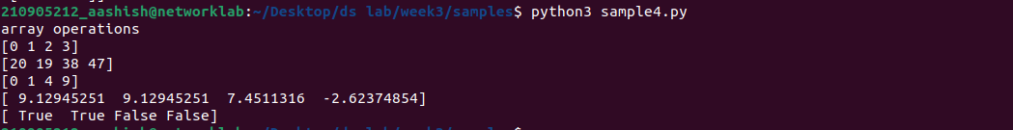
s5)
import numpy as np
print("matrix operations")
a = np.array([[1,1],[0,1]])
b = np.array([[2,0],[3,4]])
print(a*b)
print(a.dot(b))
print(np.dot(a,b))
b = np.arange(12).reshape(3,4)
print(b.sum(axis=0))
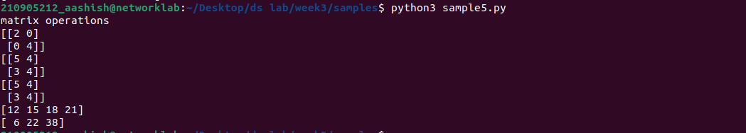
print(b.sum(axis=1))
s6)
import numpy as np
print("Indexing, Slicing & Iterating Array")
a = np.arange(10)**3
print(a)
print(a[2:5])
print(a[0:6:2])
b = np.array([[ 0, 1, 2, 3],
[10, 11, 12, 13],
[20, 21, 22, 23],
[30, 31, 32, 33],
[40, 41, 42, 43]])
print(b[2,3])
print(b[0:5,1])
print(b[:5,1])
print(b[:,1])
print("--------")
for row in b:
print(row)
print("---------")
for ele in b.flat:
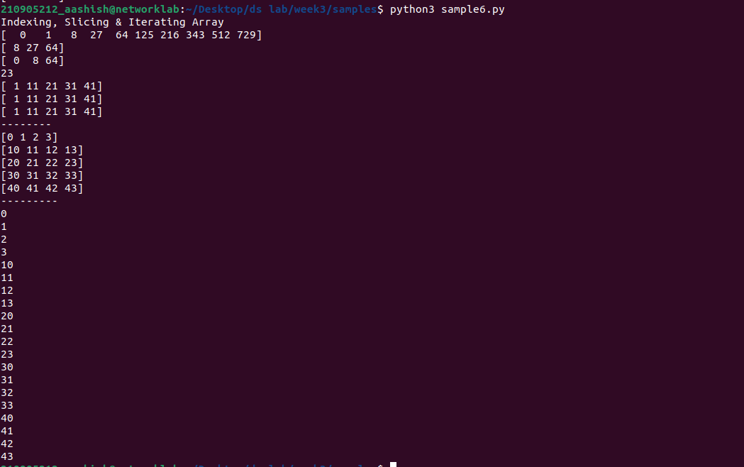
print(ele)
q7)
import numpy as np
print("Indexing, Slicing & Iterating Array")
a1 = np.array([(3,4,5),(12,6,1)])
a2 = np.array([(1,2,6),(-4,3,8)])
d1 = np.vstack((a1,a2))
print(d1)
d2 = np.hstack((a1,a2))
print(d2)

print("---------")

a = np.array([4.,2.])
b = np.array([3.,8.])
print(np.column_stack((a,b)))
print(np.hstack((a,b)))
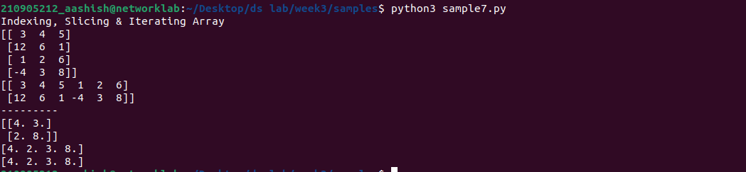
print(np.hstack((a[:2],b[:2])))

s8)

import numpy as np
a = np.arange(12)**2
print(a)
i=np.array([1,1,3,8,5])
print(a[i])
j=np.array([[3,4],[9,7]])
print(a[j])
print("----------")
a=np.array([(3,2,9),(1,6,7)])
s1=0
for row in a:
for col in row:
s1+=col
print(s1)
print("----------")
a=np.array([(3,2,9),(1,6,7)])
s=0
for i in range(a.shape[0]):
for j in range(a.shape[1]):
s+=a[i,j]

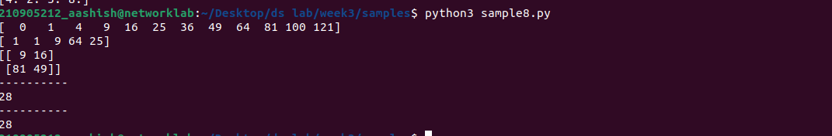
print(s)

